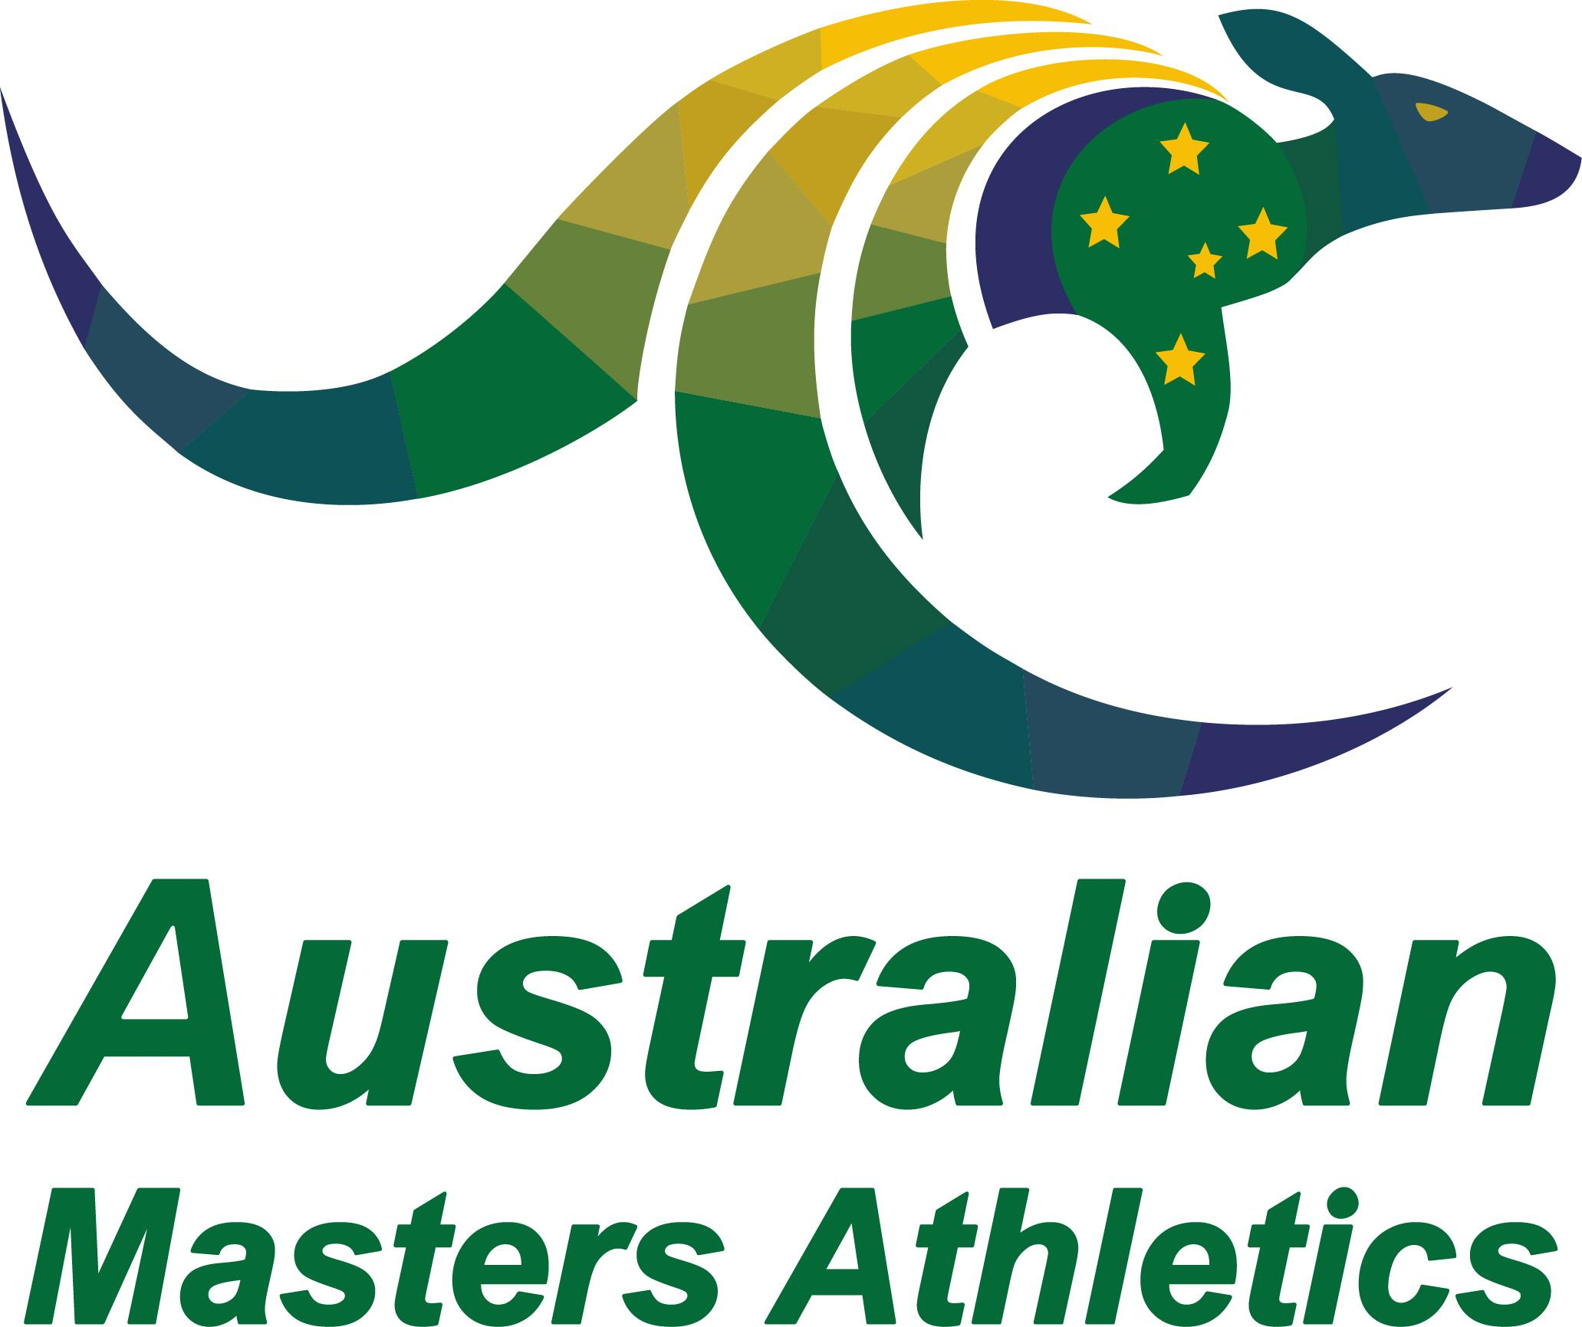 | Service Merit Award  Nomination Form

State:
Nominee
Nominee Contact Details
Nominator name and contact email (in case additional information or clarification is needed):
Seconder name and contact email (in case additional information or clarification is needed):
Verification by State / Territory body (Name, Position, State) that service details are accurate:
High resolution jpeg (at least 1MB) emailed separately to the Secretary
The nomination will be assessed against, but not limited to, the impact the nominee has had on the following areas within the sport at a state/territory, national or international level:
- Membership/Participation  - Financial  - Leadership & Planning  - Member Communications  - Compliance | - Sustainability  - Competition  - Teamwork  - Technical  - Coaching
Note: the nomination does not have to cover all areas listed above.
Using the three questions below please outline the Nominee’s Contribution to Masters Athletics.
- What is the depth of contribution in Masters athletics?
- What is the relevance and importance of the nominee's activities in Masters athletics?
- Is there anything else you would like to say to support the nomination?
Outline the Nominee’s Contribution to Masters Athletics:

In 25 words (2-3 sentences), please summarise your nomination; highlighting the achievements and impacts made. This summary will be used for all media purposes and onstage presentations at the annual dinner.

Please retain this word format and do not convert to PDF. Hand written forms will not be accepted.
Completed nomination forms are to be emailed to the AMA Secretary (secretary@australianmastersathletics.org.au) by 31 January each year.

