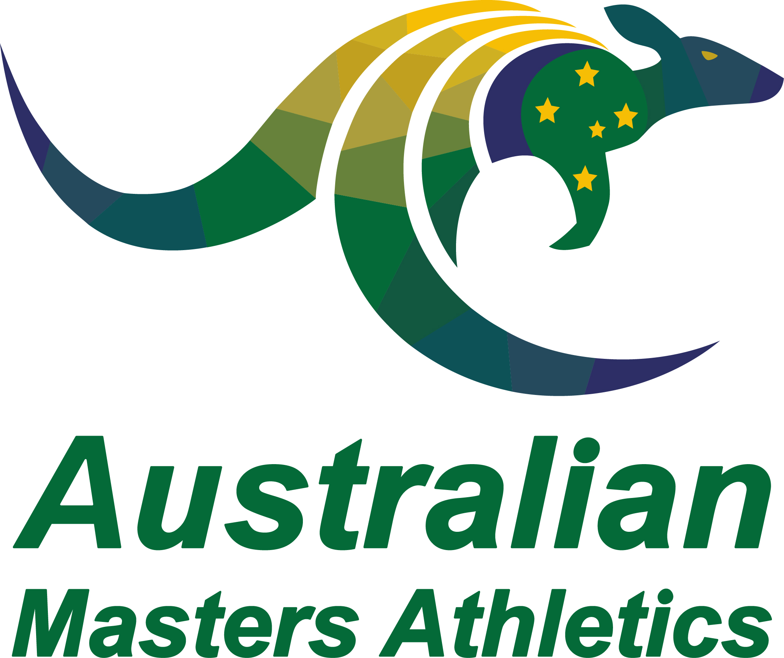 | Annual Awards  Coach Nomination Form

State:
Name:
High resolution jpeg (at least 1MB) emailed separately to the Secretary
The nomination will be assessed against, but not limited to, the following areas within the sport for the previous calendar year:
- Athlete results in Masters competitions
- Mentoring and support
- Development of Masters athletes
- Demonstrated sportsmanship towards all concerned in Masters athletics (including officials)
Name and contact email of person completing this form (in case additional information or clarification is needed):
Outline the Nominee’s Contribution to Masters Athletics:

Please retain this word format and do not convert to PDF. Hand written forms will not be accepted.
Completed nomination forms are to be emailed to the AMA Secretary (secretary@australianmastersathletics.org.au) by 31 January each year.

