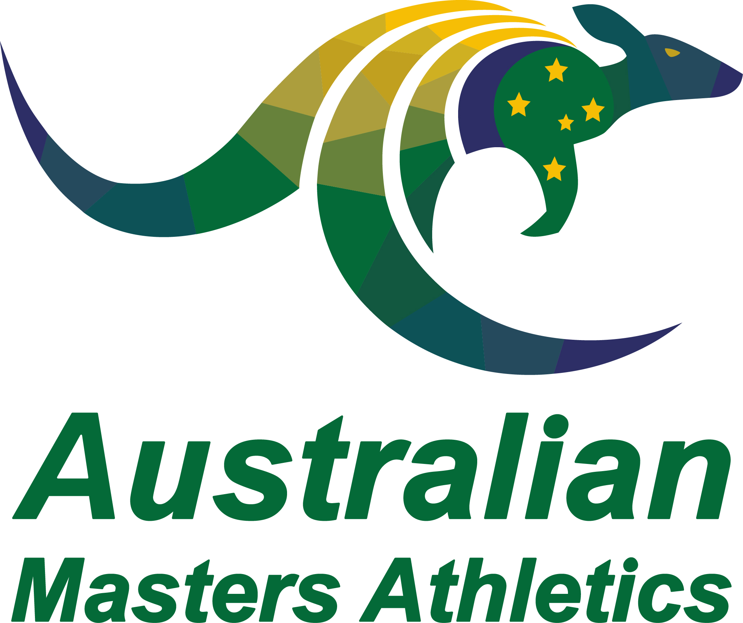 | AMA Service Merit Award Nomination Form

Award Criteria
1. The Service Merit Award may be made by Australian Masters Athletics Inc. to any person in recognition of outstanding service to masters athletics in any state or territory. Any registered member can nominate another member.
2. A person nominated for this award shall have recorded at least twelve (12) years of service to masters athletics, however it is not necessary that this service be continuous.
3. The person nominated will have served as a competitor, official, administrator or in some other capacity, or any combination of these, during the period of service.
4. Nominations must be received in writing on the appropriate application form and under such terms and conditions as set down by Australian Masters Athletics Inc. from time to time.
5. The application for nomination should be detailed, including relevant dates, the contribution made by the nominee to the sport and should also list any outstanding achievements over and above regular service to athletics.

State:
Nominee:
Nominee Contact Details:
High resolution jpeg (at least 1MB) emailed separately to the Secretary
Outline the Nominee’s Service to Masters Athletics
State:

National:

World:

Other information which may assist the nomination:

Nominator name and contact email (in case additional information or clarification is needed):
Seconder – name and contact email:
Verification by State / Territory body (Name, Position, State) that service details are accurate:

Please retain this word format and do not convert to PDF.

Completed nomination forms are to be emailed to the AMA Secretary (secretary@australianmastersathletics.org.au) by 31 January each year.

