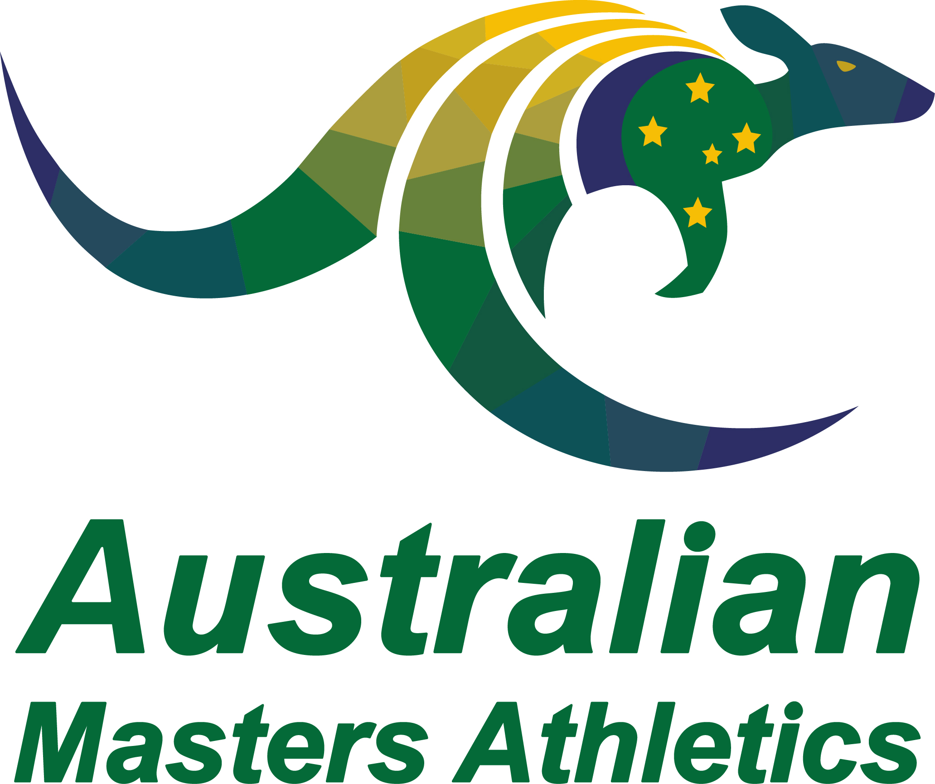 | Annual Awards – Administrator  Nomination Form

State:
Name:
High resolution jpeg (at least 1MB) emailed separately to the Secretary
Outline the Nominee’s Contribution to Masters Athletics:
Name and contact email of person completing this form (in case additional information or clarification is needed):

Please retain this word format and do not convert to PDF. Hand written forms will not be accepted.
Completed nomination forms are to be emailed to the AMA Secretary (secretary@australianmastersathletics.org.au) by 31 January each year.

